**DOCKER SWARM**

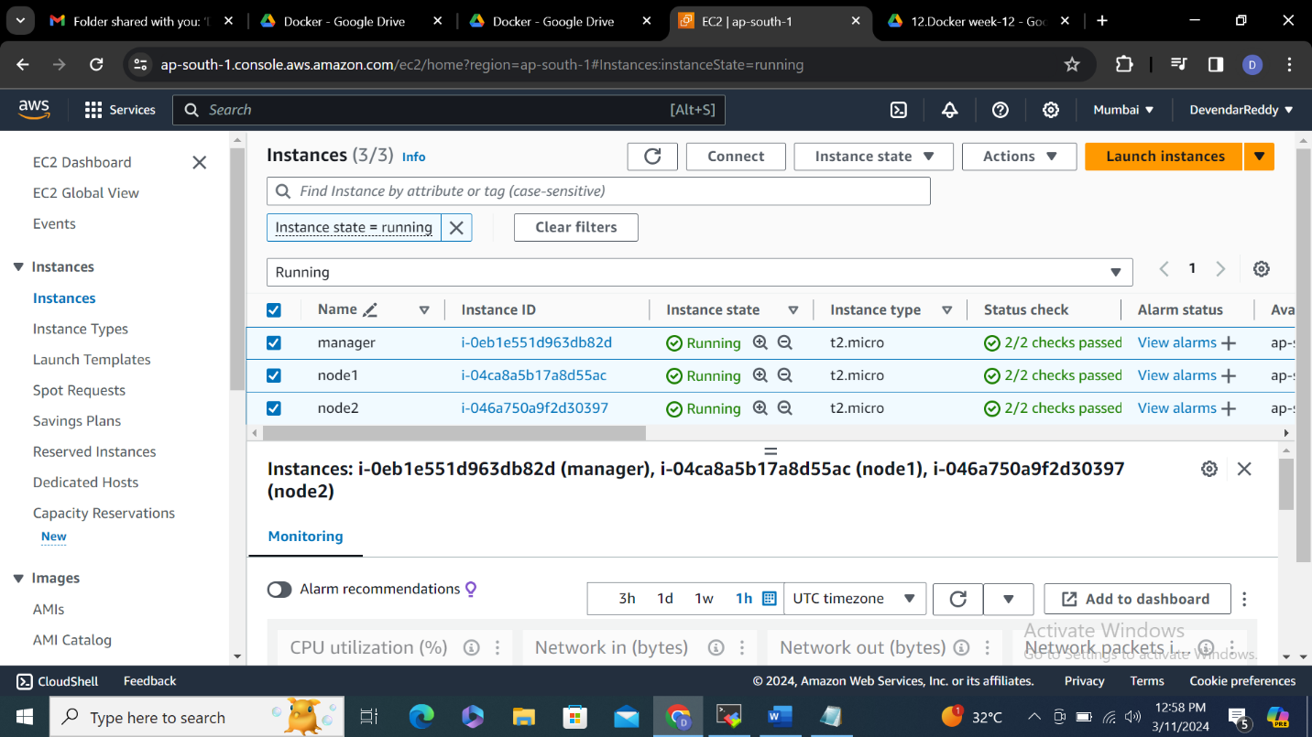

**Log into 3 nodes and do the following steps**

**1.** **yum update -y**

**2.** **yum install docker -y**

**3.** **systemctl start docker**

**4.** **usermod -a -G docker ec2-user**

**5. Enter docker swarm init in the manager node you will get id**

**6.** **docker swarm join --token SWMTKN-1-024jtumcnu50mv9izcg8gs1n3f6febv6pi0kr9aauemctexoi1-co18lc6rn4qfqn64jwpya8hj7 172.31.14.225:2377**

**7.Enter docker join cmd in node1,2 you will see this node joined a swarm as worker**

**Manger node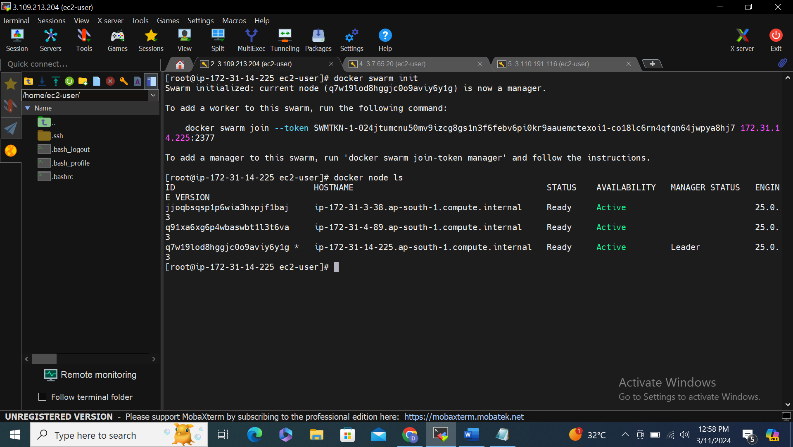Node-1**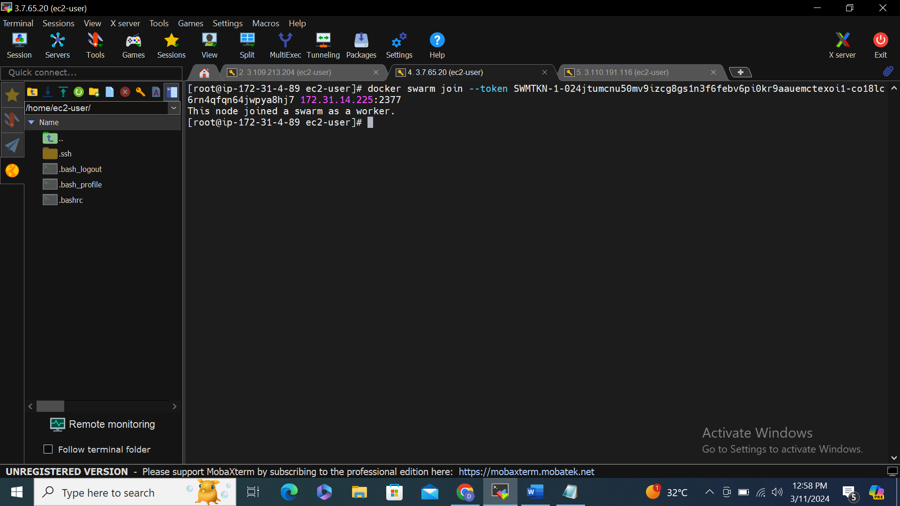

**Node-2**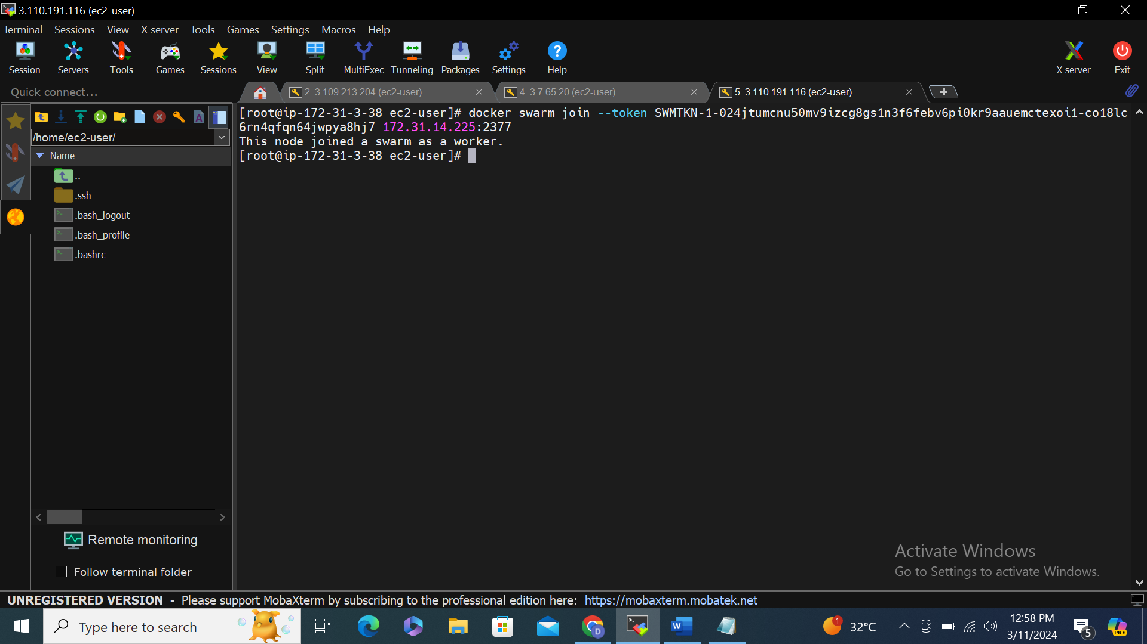

**Finally after adding manager in 2 worker nodes**

